**Merit Report** James C Dickens, PhD American University Professorial Lecturer

From January 1, 2019 to April 30, 2021, the following accomplishments and service are items that I would like to feature and report on:

* Typically, Term faculty members teach 5 courses per academic year, an assignment of 3 courses in the fall and 2 courses in the spring or 2 courses in the spring and 3 courses in the fall. I have consistently taught 3 courses per semester for the last 2 years 2020 and 2021.
* The summer of 2019 I taught precalculus in the STEP program in order to academically prepare recently high school graduates for the academic rigor of college mathematics classes starting in the Fall of 2019.
* I was recruited in the spring semester of 2019 to teach in the Data Science Program by Dr. Jane Wall and began teaching the Introductory R Programming course In the Fall semester of 2019 . That particular semester I taught three courses / three different preparations.
* Spring semester of 2020 I successfully taught 3 courses in the Data Science Program and made adjustments to an asynchronous teaching delivery system after the semester was interrupted.
* I successfully taught two online Precalculus courses in the Summer of 2020; on course was synchronous and the other was asynchronous. I also supervised an independent study/internship experience for a Data Science student who was working for a government agency for the country of [United Arab Emirates](https://en.wikipedia.org/wiki/United_Arab_Emirates)
* During the Summer Session of 2020, I participated in a collaboration and sharing effort involving 3 AU faculty members from different disciplines to investigate best practices for online teaching.
* During the Summer of 2020, working collaboratively with Dr. Jane Wall and Dr Nathan Harshman, I was instrumental in establishing a relationship with the District of Columbia Public School System in order to introduce students, teachers, and staff to the field of Data Science. Our team was able to recruit selected teachers who enrolled in the Introduction to R Programming Course in the spring of 2021.
* Fall of 2020; worked collaboratively with team members of the NASA Space Grant Consortium to develop promotional and recruitment flyers to recruit teachers and students for matriculation opportunities in Data Science at American University.
* At the beginning of the Spring Semester 2021, I led an effort to recruit faculty members to serve as academic advisors for the six DCPS teachers who were matriculating in or Data Science Program. I served as one of the advisors.
* Spring semester 2021: helped with the preparation and orientation of new adjunct faculty members who were assigned to teach STAT 412/612
* During the Spring semester of 2021, I served on a committee headed by Mike Limarzi to collect and process perspectives, best practices, and observations regarding online teaching.
* The Fall of 2020 ( December 1st ): Presented to a panel of Data Science Professionals on the objectives and status of the partnership with the DC public schools. This event was hosted by the Data Science Advisory Board.
* A journal article of mine was published in March of 2021: **CHANCE** Using Data to Advance Science, Education, and Society; *The Data Science Public Schools Outreach Project: An Initiative for Diversity and Inclusion in Statistics*
* April 9th of 2021: Interviewed and shared perspectives on Data Science to a panel of journalists and faculty members of Miami University of Ohio. The event (Stats + Stories) was hosted by Miami University of Ohio.

SET’s Summer 2020

[American University Washington D.C.](https://myau.american.edu/)

**2020X-MATH-170-003 Precalculus Mathematics (James Dickens)**

Project Title

American University Student Evaluation of Teaching (SET) Summer 2020

Courses Audience

14

Responses Received

7

Response Ratio

50%

Creation Date

Thursday, September 03, 2020

[Technology powered by BLUE](http://www.explorance.com/)

[Download PDF](https://american.bluera.com/american/rdrpl.aspx?rid=06f38c74-79ed-4065-96cd-feefdf835ca9&crid=ce38188a-5240-4cf1-9453-470627a52001&lang=en-US&reporttype=2)

**American University Washington D.C.**

**American University Student Evaluation of Teaching**

|  |
| --- |
| **Interpretation guidelines** |

All single-response questions are represented by a rating, or Likert-type scale. The value "5" generally represents a "fulfilled" or positive connotation, while the value "1" generally maintains an unsatisfied connotation.  
  
The value 5 may take one of several forms that include:

* Strongly Agree
* Almost Always
* Very Satisfied

The value 1, conversely, may take one of several forms that include:

* Strongly Disagree
* Almost Never
* Not Satisfied

Keep in mind that despite completing an evaluation, students were not required to submit answers to every question. As a result, you may notice that the total number of responses is lower on some items than on others. In these cases, the student decided to skip this question. Students also may have skipped the open-ended questions, thus leaving fewer responses in these sections as well.

|  |  |
| --- | --- |
| Teacher | Course |
| **James Dickens** | **MATH-170-003 Precalculus Mathematics** |

**Questions relating to James Dickens**

**The professor required high levels of performance**

The professor required high levels of performance.

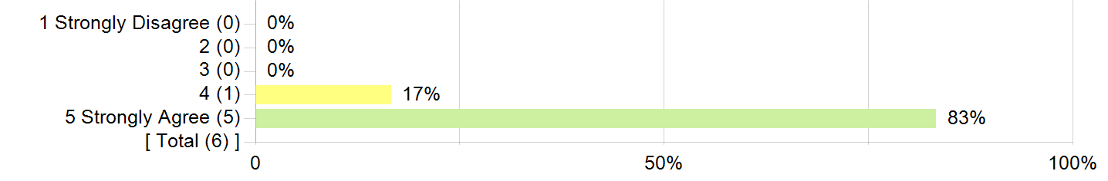

| Table for The professor required high levels of performance-The professor required high levels of performance.-Statistics. | |
| --- | --- |
| **Statistics** | **Value** |
| **Mean** | 4.83 |
| **Median** | 5.00 |
| **Standard Deviation** | 0.41 |

**Comparative Scores:**

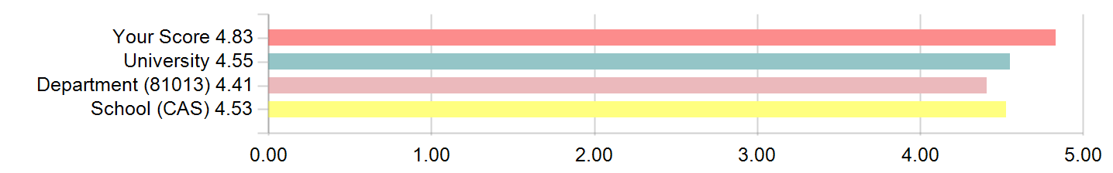

**The professor presented the material clearly.**

The professor presented the material clearly.

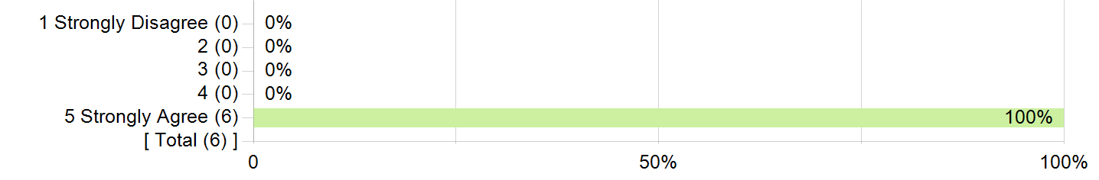

| Table for The professor presented the material clearly.-The professor presented the material clearly.-Statistics. | |
| --- | --- |
| **Statistics** | **Value** |
| **Mean** | 5.00 |
| **Median** | 5.00 |
| **Standard Deviation** | 0.00 |

**Comparative Scores:**

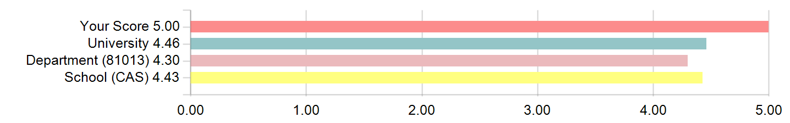

**The professor facilitated a respectful learning environment.**

The professor facilitated a respectful learning environment.



| Table for The professor facilitated a respectful learning environment. -The professor facilitated a respectful learning environment. -Statistics. | |
| --- | --- |
| **Statistics** | **Value** |
| **Mean** | 4.83 |
| **Median** | 5.00 |
| **Standard Deviation** | 0.41 |

**Comparative Scores:**

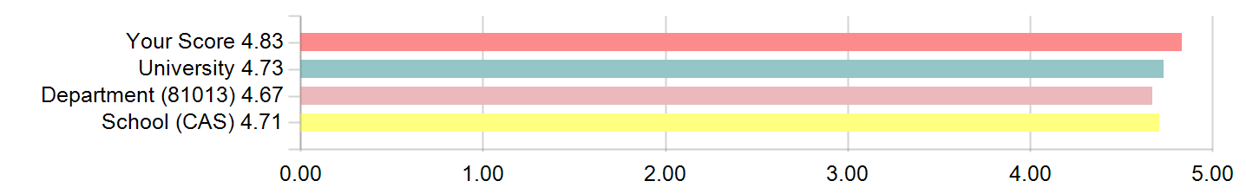

**The professor was responsive to students' questions and comments.**

The professor was responsive to students' questions and comments.

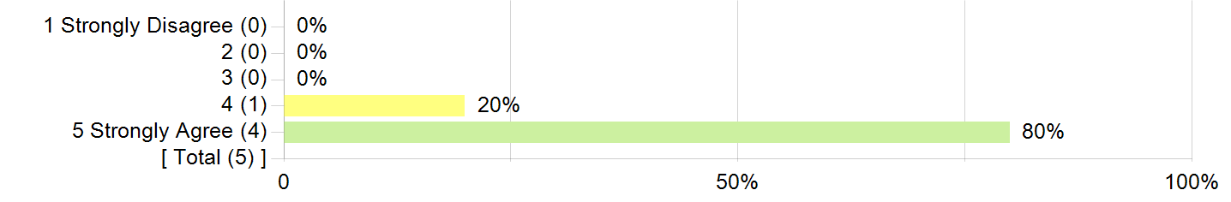

| Table for The professor was responsive to students' questions and comments. -The professor was responsive to students' questions and comments.-Statistics. | |
| --- | --- |
| **Statistics** | **Value** |
| **Mean** | 4.80 |
| **Median** | 5.00 |
| **Standard Deviation** | 0.45 |

**Comparative Scores:**

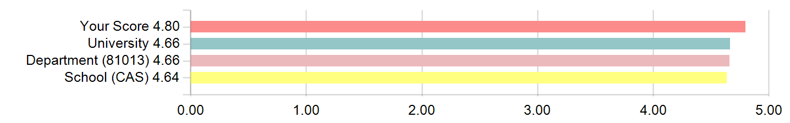

**The professor was available for conversations or questions outside of the designated class time.**

The professor was available for conversations or questions outside of the designated class time.

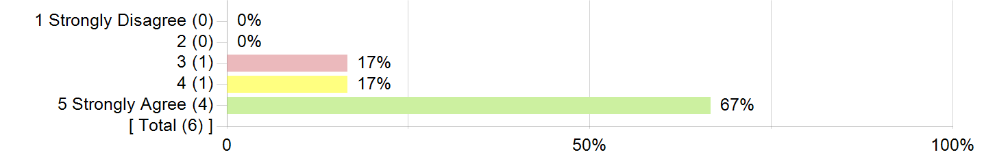

| Table for The professor was available for conversations or questions outside of the designated class time.-The professor was available for conversations or questions outside of the designated class time. -Statistics. | |
| --- | --- |
| **Statistics** | **Value** |
| **Mean** | 4.50 |
| **Median** | 5.00 |
| **Standard Deviation** | 0.84 |

**Comparative Scores:**

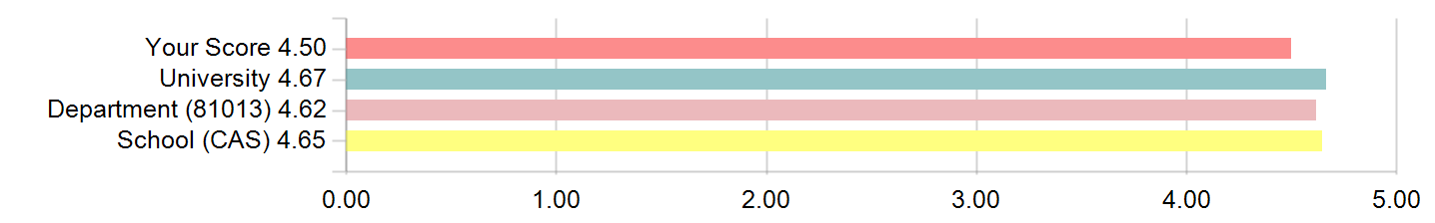

**The professor provided constructive feedback on papers, tests, or other assignments as appropriate.**

The professor provided constructive feedback on papers, tests, or other assignments as appropriate.



| Table for The professor provided constructive feedback on papers, tests, or other assignments as appropriate. -The professor provided constructive feedback on papers, tests, or other assignments as appropriate. -Statistics. | |
| --- | --- |
| **Statistics** | **Value** |
| **Mean** | 4.83 |
| **Median** | 5.00 |
| **Standard Deviation** | 0.41 |

**Comparative Scores:**

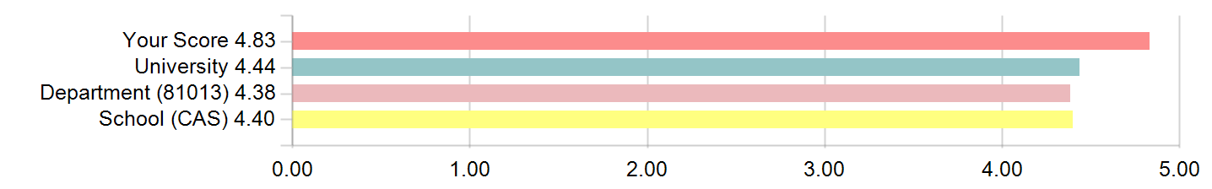

**I would recommend this professor to other students.**

I would recommend this professor to other students.



| Table for I would recommend this professor to other students. -I would recommend this professor to other students. -Statistics. | |
| --- | --- |
| **Statistics** | **Value** |
| **Mean** | 4.83 |
| **Median** | 5.00 |
| **Standard Deviation** | 0.41 |

**Comparative Scores:**

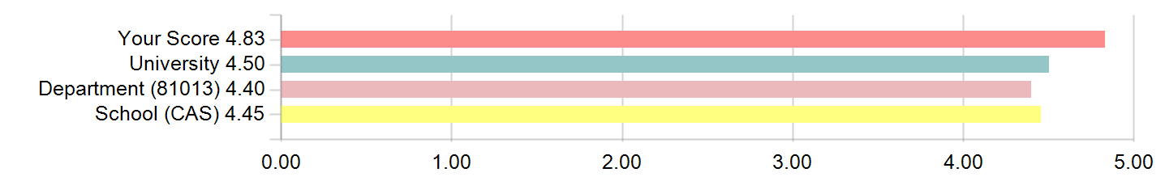

**Instructor related questions summary: Top and bottom values**

| Table for Instructor related questions summary: Top and bottom values-Strengths. | | | | | |
| --- | --- | --- | --- | --- | --- |
| **Strengths** | | | | | |
| **1** | | The professor presented the material clearly. | Instructor | 5.00 | |
| **2** | | The professor required high levels of performance. | Instructor | 4.83 | |
| Table for Instructor related questions summary: Top and bottom values-Areas for Improvement. | | | | | | | |
| **Areas for Improvement** | | | | | | | |
| **1** | The professor was available for conversations or questions outside of the designated class time. | | | | Instructor | | 4.50 |
| **2** | The professor was responsive to students' questions and comments. | | | | Instructor | | 4.80 |

**Course Questions**

**This course challenged me to do my best work.**

This course challenged me to do my best work.



| Table for This course challenged me to do my best work. -This course challenged me to do my best work. -Statistics. | |
| --- | --- |
| **Statistics** | **Value** |
| **Mean** | 4.50 |
| **Median** | 5.00 |
| **Standard Deviation** | 0.84 |

**Comparative Scores:**

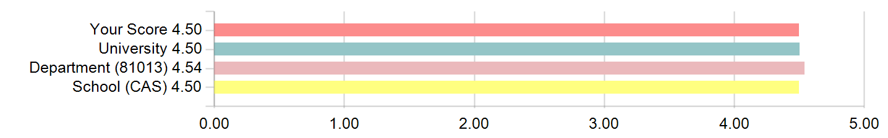

**The learning objectives for this course were clear.**

The learning objectives for this course were clear.



| Table for The learning objectives for this course were clear.-The learning objectives for this course were clear.-Statistics. | |
| --- | --- |
| **Statistics** | **Value** |
| **Mean** | 4.50 |
| **Median** | 5.00 |
| **Standard Deviation** | 0.84 |

**Comparative Scores:**

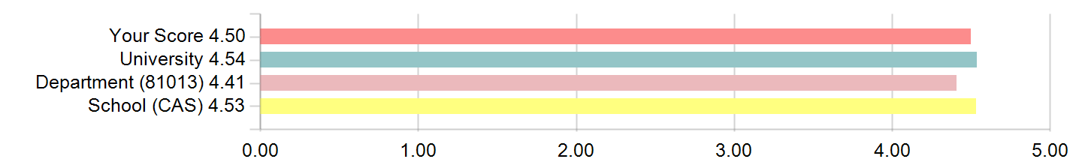

**The activities, readings, and assignments reflected the learning objectives for the course.**

The activities, readings, and assignments reflected the learning objectives for the course.



| Table for The activities, readings, and assignments reflected the learning objectives for the course. -The activities, readings, and assignments reflected the learning objectives for the course. -Statistics. | |
| --- | --- |
| **Statistics** | **Value** |
| **Mean** | 4.83 |
| **Median** | 5.00 |
| **Standard Deviation** | 0.41 |

**Comparative Scores:**

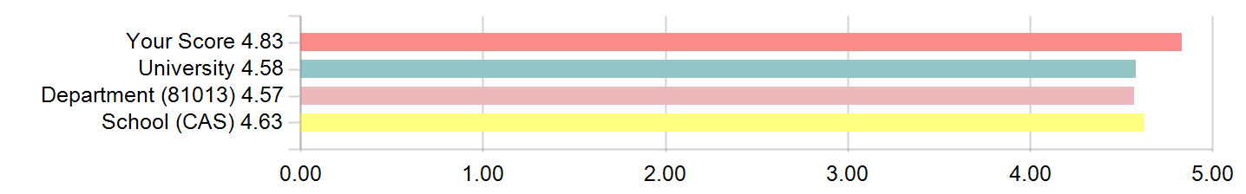

**I now have a greater understanding of the subject matter of this course.**

I now have a greater understanding of the subject matter of this course.



| Table for I now have a greater understanding of the subject matter of this course. -I now have a greater understanding of the subject matter of this course. -Statistics. | |
| --- | --- |
| **Statistics** | **Value** |
| **Mean** | 4.83 |
| **Median** | 5.00 |
| **Standard Deviation** | 0.41 |

**Comparative Scores:**

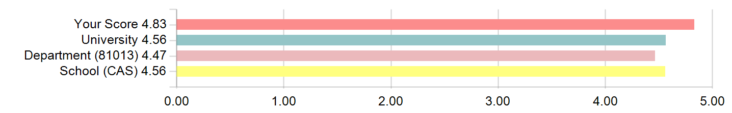

**Indicate the average number of hours per week you worked on assignments and studied for this course**

Indicate the average number of hours per week you worked on assignments and studied for this course

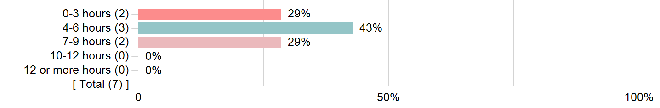

**I improved my quantitative reasoning skills in this course.**

I improved my quantitative reasoning skills in this course.



| Table for I improved my quantitative reasoning skills in this course. -I improved my quantitative reasoning skills in this course.-Statistics. | |
| --- | --- |
| **Statistics** | **Value** |
| **Mean** | 4.80 |
| **Standard Deviation** | 0.45 |

**The amount of time devoted to discussion in class is just about right.**

The amount of time devoted to discussion in class is just about right.

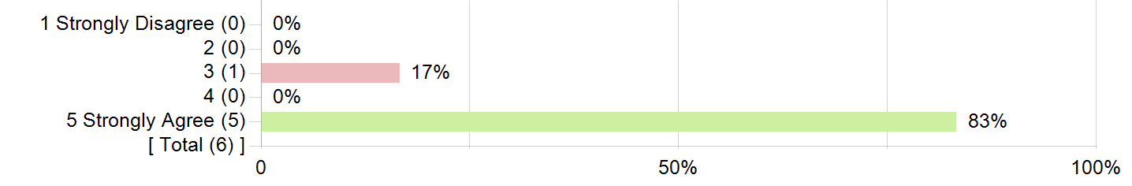

| Table for The amount of time devoted to discussion in class is just about right. -The amount of time devoted to discussion in class is just about right.-Statistics. | |
| --- | --- |
| **Statistics** | **Value** |
| **Mean** | 4.67 |
| **Standard Deviation** | 0.82 |

**The computer aided instruction is a valuable part of this course.**

The computer aided instruction is a valuable part of this course.

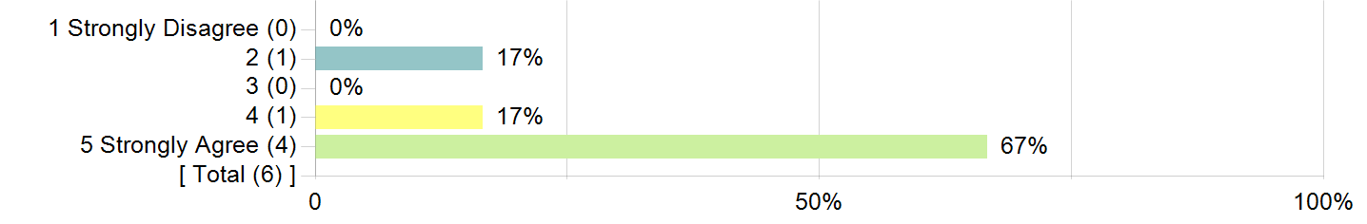

| Table for The computer aided instruction is a valuable part of this course. -The computer aided instruction is a valuable part of this course.-Statistics. | |
| --- | --- |
| **Statistics** | **Value** |
| **Mean** | 4.33 |
| **Standard Deviation** | 1.21 |

**Examinations are graded carefully and fairly.**

Examinations are graded carefully and fairly.

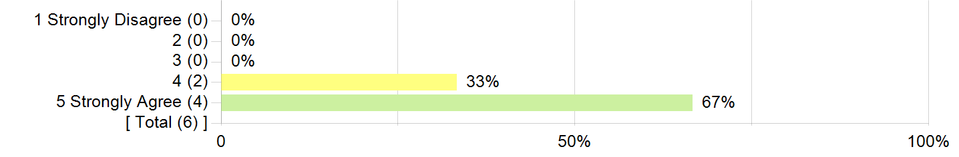

| Table for Examinations are graded carefully and fairly. -Examinations are graded carefully and fairly.-Statistics. | |
| --- | --- |
| **Statistics** | **Value** |
| **Mean** | 4.67 |
| **Standard Deviation** |  |

[American University Washington D.C.](https://myau.american.edu/)

**2020X-MATH-170-001 Precalculus Mathematics (James Dickens)**

Project Title

American University Student Evaluation of Teaching (SET) Summer 2020

Courses Audience

24

Responses Received

12

Response Ratio

50%

Creation Date

Thursday, September 03, 2020

[Technology powered by BLUE](http://www.explorance.com/)

[Download PDF](https://american.bluera.com/american/rdrpl.aspx?rid=06f38c74-79ed-4065-96cd-feefdf835ca9&crid=563cb5e7-d3dd-4ad9-93be-663d8df7c63e&lang=en-US&reporttype=2)

**American University Washington D.C.**

**American University Student Evaluation of Teaching**

|  |
| --- |
| **Interpretation guidelines** |

All single-response questions are represented by a rating, or Likert-type scale. The value "5" generally represents a "fulfilled" or positive connotation, while the value "1" generally maintains an unsatisfied connotation.  
  
The value 5 may take one of several forms that include:

* Strongly Agree
* Almost Always
* Very Satisfied

The value 1, conversely, may take one of several forms that include:

* Strongly Disagree
* Almost Never
* Not Satisfied

Keep in mind that despite completing an evaluation, students were not required to submit answers to every question. As a result, you may notice that the total number of responses is lower on some items than on others. In these cases, the student decided to skip this question. Students also may have skipped the open-ended questions, thus leaving fewer responses in these sections as well.

|  |  |
| --- | --- |
| Teacher | Course |
| **James Dickens** | **MATH-170-001 Precalculus Mathematics** |

**Questions relating to James Dickens**

**The professor required high levels of performance**

The professor required high levels of performance.

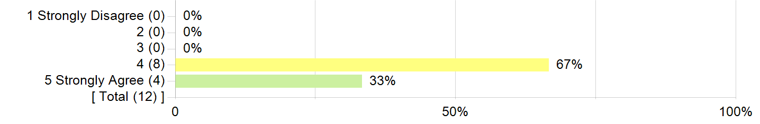

| Table for The professor required high levels of performance-The professor required high levels of performance.-Statistics. | |
| --- | --- |
| **Statistics** | **Value** |
| **Mean** | 4.33 |
| **Median** | 4.00 |
| **Standard Deviation** | 0.49 |

**Comparative Scores:**

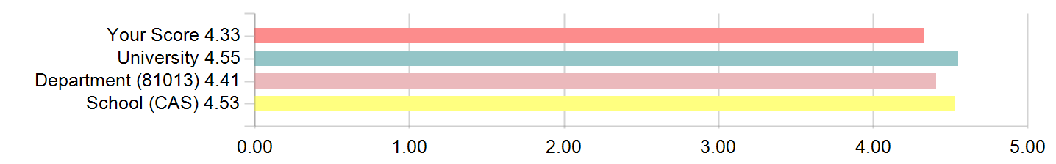

**The professor presented the material clearly.**

The professor presented the material clearly.

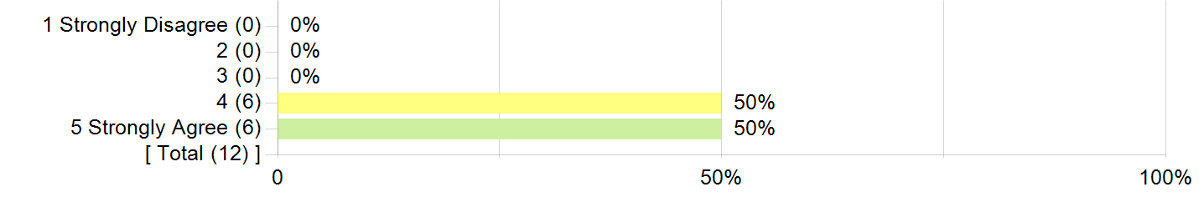

| Table for The professor presented the material clearly.-The professor presented the material clearly.-Statistics. | |
| --- | --- |
| **Statistics** | **Value** |
| **Mean** | 4.50 |
| **Median** | 4.50 |
| **Standard Deviation** | 0.52 |

**Comparative Scores:**

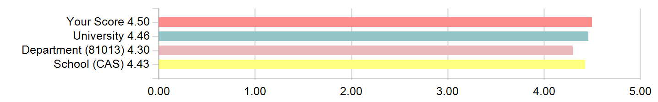

**The professor facilitated a respectful learning environment.**

The professor facilitated a respectful learning environment.

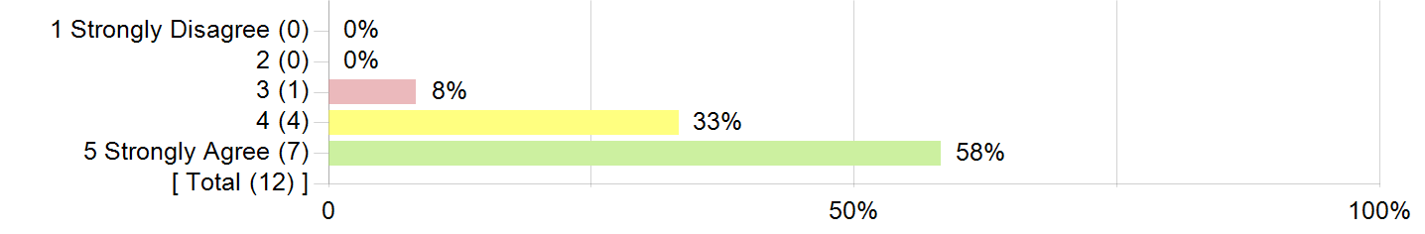

| Table for The professor facilitated a respectful learning environment. -The professor facilitated a respectful learning environment. -Statistics. | |
| --- | --- |
| **Statistics** | **Value** |
| **Mean** | 4.50 |
| **Median** | 5.00 |
| **Standard Deviation** | 0.67 |

**Comparative Scores:**

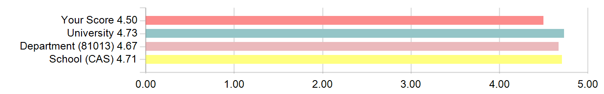

**The professor was responsive to students' questions and comments.**

The professor was responsive to students' questions and comments.

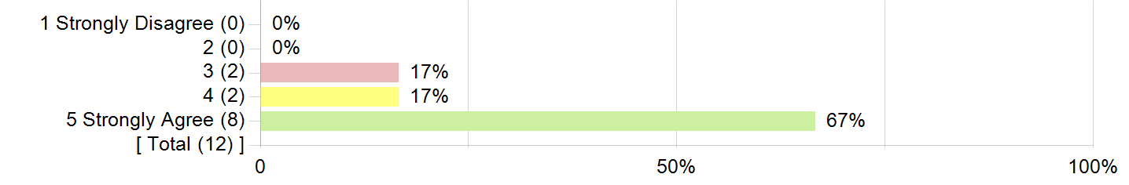

| Table for The professor was responsive to students' questions and comments. -The professor was responsive to students' questions and comments.-Statistics. | |
| --- | --- |
| **Statistics** | **Value** |
| **Mean** | 4.50 |
| **Median** | 5.00 |
| **Standard Deviation** | 0.80 |

**Comparative Scores:**

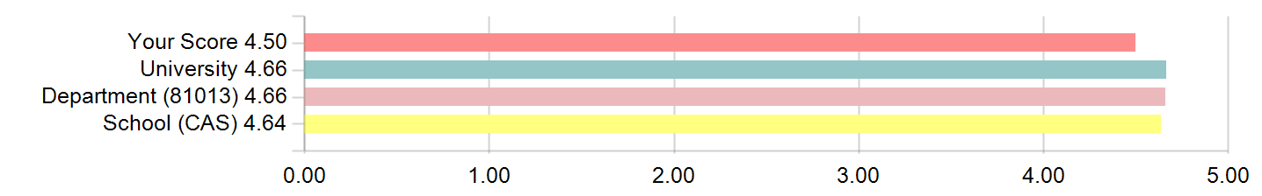

**The professor was available for conversations or questions outside of the designated class time.**

The professor was available for conversations or questions outside of the designated class time.

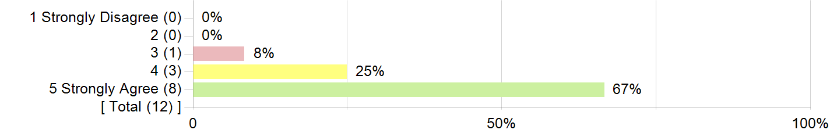

| Table for The professor was available for conversations or questions outside of the designated class time.-The professor was available for conversations or questions outside of the designated class time. -Statistics. | |
| --- | --- |
| **Statistics** | **Value** |
| **Mean** | 4.58 |
| **Median** | 5.00 |
| **Standard Deviation** | 0.67 |

**Comparative Scores:**

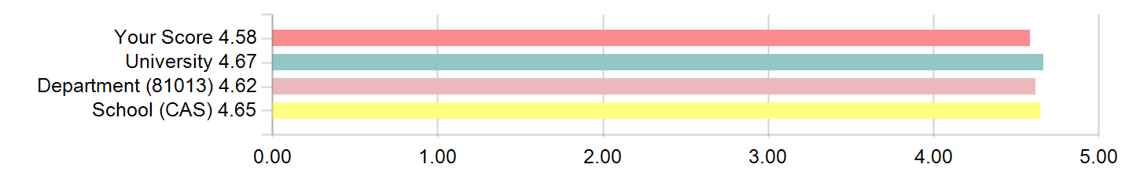

**The professor provided constructive feedback on papers, tests, or other assignments as appropriate.**

The professor provided constructive feedback on papers, tests, or other assignments as appropriate.

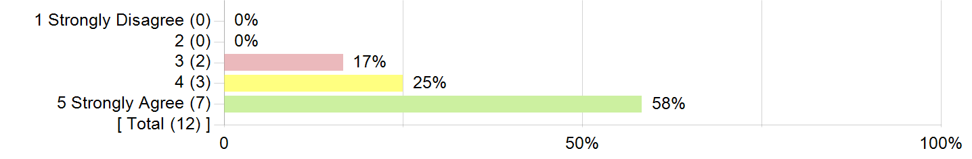

| Table for The professor provided constructive feedback on papers, tests, or other assignments as appropriate. -The professor provided constructive feedback on papers, tests, or other assignments as appropriate. -Statistics. | |
| --- | --- |
| **Statistics** | **Value** |
| **Mean** | 4.42 |
| **Median** | 5.00 |
| **Standard Deviation** | 0.79 |

**Comparative Scores:**

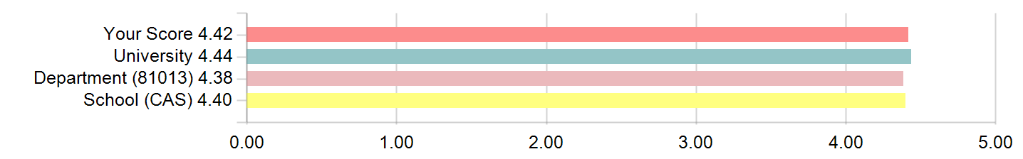

**I would recommend this professor to other students.**

I would recommend this professor to other students.



| Table for I would recommend this professor to other students. -I would recommend this professor to other students. -Statistics. | |
| --- | --- |
| **Statistics** | **Value** |
| **Mean** | 4.42 |
| **Median** | 5.00 |
| **Standard Deviation** | 0.79 |

**Comparative Scores:**

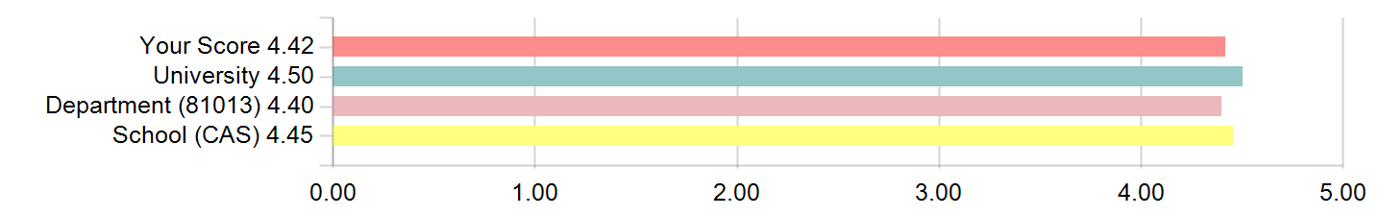

**Instructor related questions summary: Top and bottom values**

| Table for Instructor related questions summary: Top and bottom values-Strengths. | | | |
| --- | --- | --- | --- |
| **Strengths** | | | |
| **1** | The professor was available for conversations or questions outside of the designated class time. | Instructor | 4.58 |
| **2** | The professor presented the material clearly. | Instructor | 4.50 |
| Table for Instructor related questions summary: Top and bottom values-Areas for Improvement. | | | |
| **Areas for Improvement** | | | |
| **1** | The professor required high levels of performance. | Instructor | 4.33 |
| **2** | The professor provided constructive feedback on papers, tests, or other assignments as appropriate. | Instructor | 4.42 |

**Course Questions**

**This course challenged me to do my best work.**

This course challenged me to do my best work.



| Table for This course challenged me to do my best work. -This course challenged me to do my best work. -Statistics. | |
| --- | --- |
| **Statistics** | **Value** |
| **Mean** | 4.42 |
| **Median** | 5.00 |
| **Standard Deviation** | 0.79 |

**Comparative Scores:**

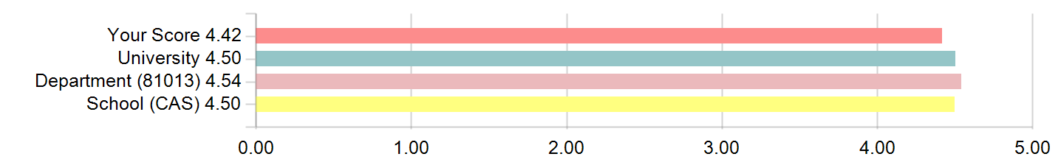

**The learning objectives for this course were clear.**

The learning objectives for this course were clear.



| Table for The learning objectives for this course were clear.-The learning objectives for this course were clear.-Statistics. | |
| --- | --- |
| **Statistics** | **Value** |
| **Mean** | 4.58 |
| **Median** | 5.00 |
| **Standard Deviation** | 0.67 |

**Comparative Scores:**

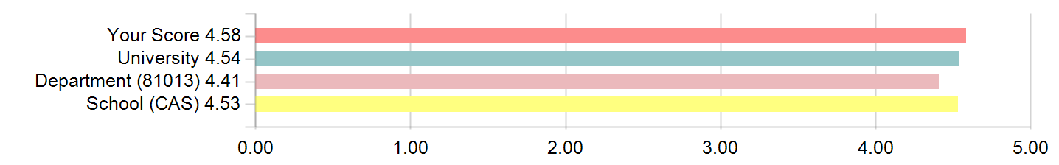

**The activities, readings, and assignments reflected the learning objectives for the course.**

The activities, readings, and assignments reflected the learning objectives for the course.

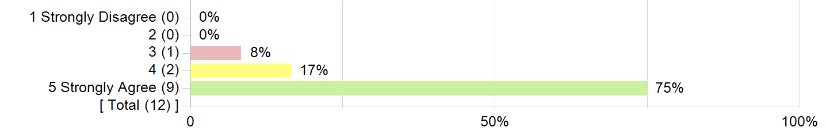

| Table for The activities, readings, and assignments reflected the learning objectives for the course. -The activities, readings, and assignments reflected the learning objectives for the course. -Statistics. | |
| --- | --- |
| **Statistics** | **Value** |
| **Mean** | 4.67 |
| **Median** | 5.00 |
| **Standard Deviation** | 0.65 |

**Comparative Scores:**

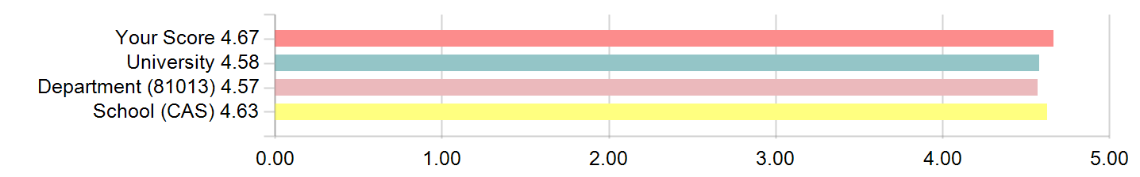

**I now have a greater understanding of the subject matter of this course.**

I now have a greater understanding of the subject matter of this course.



| Table for I now have a greater understanding of the subject matter of this course. -I now have a greater understanding of the subject matter of this course. -Statistics. | |
| --- | --- |
| **Statistics** | **Value** |
| **Mean** | 4.42 |
| **Median** | 5.00 |
| **Standard Deviation** | 0.79 |

**Comparative Scores:**

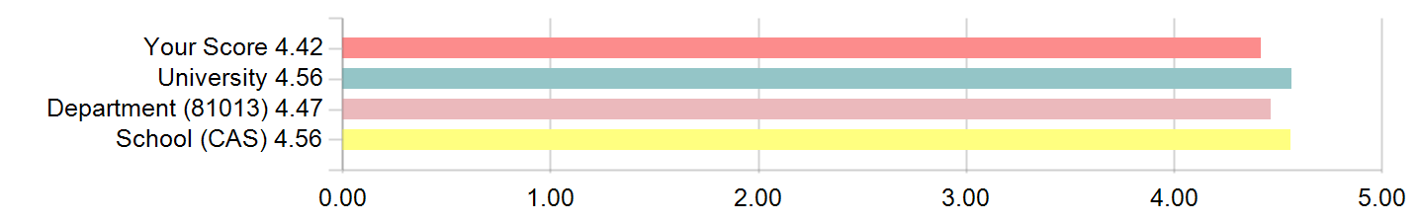

**Indicate the average number of hours per week you worked on assignments and studied for this course**

Indicate the average number of hours per week you worked on assignments and studied for this course

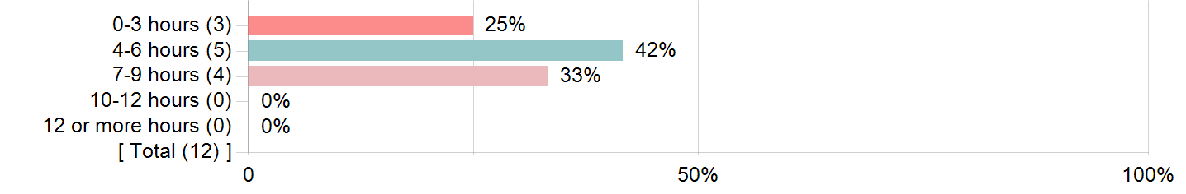

**I improved my quantitative reasoning skills in this course.**

I improved my quantitative reasoning skills in this course.

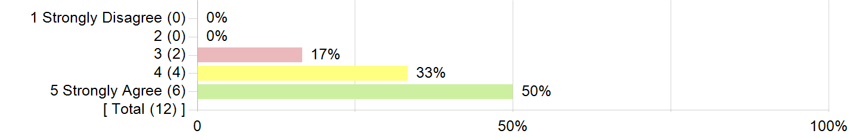

| Table for I improved my quantitative reasoning skills in this course. -I improved my quantitative reasoning skills in this course.-Statistics. | |
| --- | --- |
| **Statistics** | **Value** |
| **Mean** | 4.33 |
| **Standard Deviation** | 0.78 |

**The amount of time devoted to discussion in class is just about right.**

The amount of time devoted to discussion in class is just about right.



| Table for The amount of time devoted to discussion in class is just about right. -The amount of time devoted to discussion in class is just about right.-Statistics. | |
| --- | --- |
| **Statistics** | **Value** |
| **Mean** | 4.50 |
| **Standard Deviation** | 0.80 |

**The computer aided instruction is a valuable part of this course.**

The computer aided instruction is a valuable part of this course.

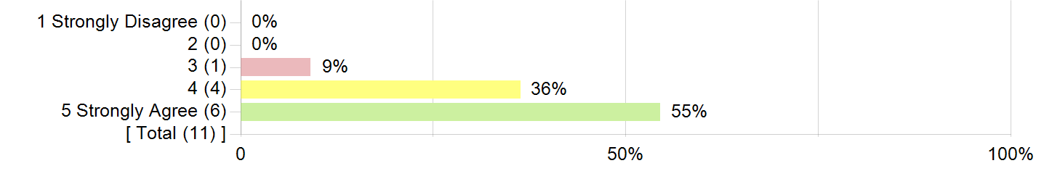

| Table for The computer aided instruction is a valuable part of this course. -The computer aided instruction is a valuable part of this course.-Statistics. | |
| --- | --- |
| **Statistics** | **Value** |
| **Mean** | 4.45 |
| **Standard Deviation** | 0.69 |

**Examinations are graded carefully and fairly.**

Examinations are graded carefully and fairly.



| Table for Examinations are graded carefully and fairly. -Examinations are graded carefully and fairly.-Statistics. | |
| --- | --- |
| **Statistics** | **Value** |
| **Mean** | 4.50 |
| **Standard Deviation** |  |